**Websites that you consider well designed from a UI perspective**

**W**ebsites are something which we can see on our screen. Good website is one which has good visual appeal ,easy to navigate, user friendly, accessible, clean and professional with good colour schema and zero errors, well organized are more importantly can be loads super-fast from anywhere in world and now yes responsive. Website which I consider well design are:

* **Myntra (https://www.myntra.com)**
* **Pitch (https://pitch.com/)**
* **Airbnb (**[**https://www.airbnb.co.uk/**](https://www.airbnb.co.uk/)**)**

1. **Myntra**

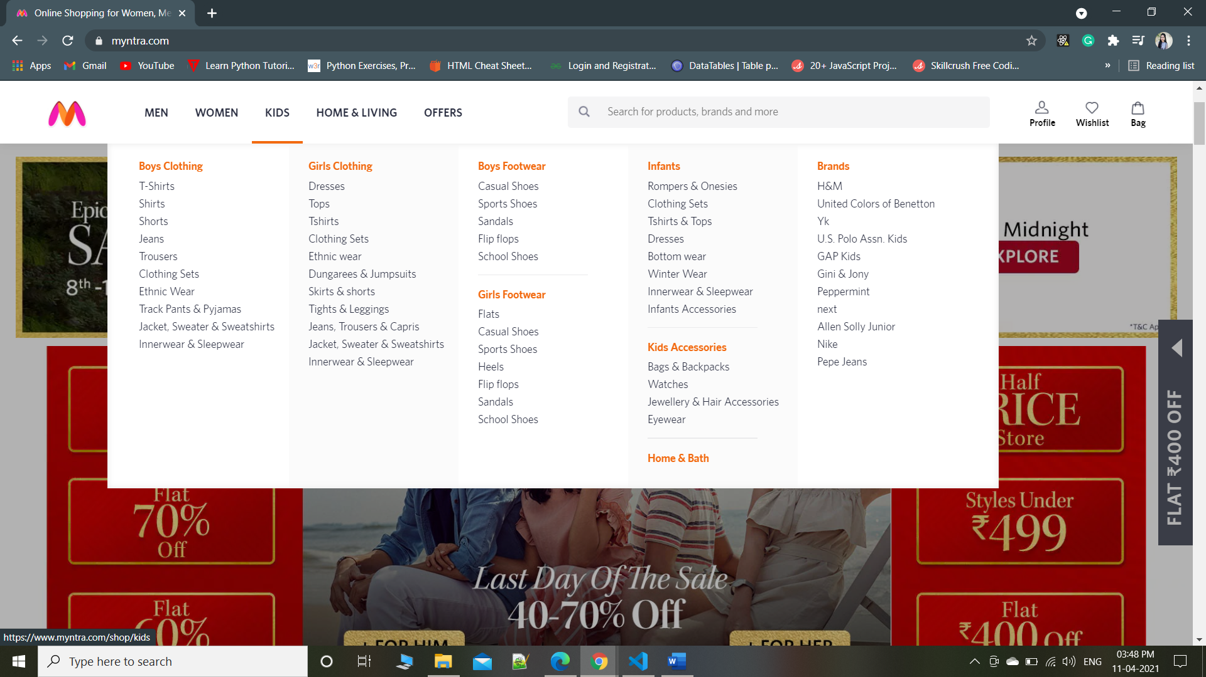

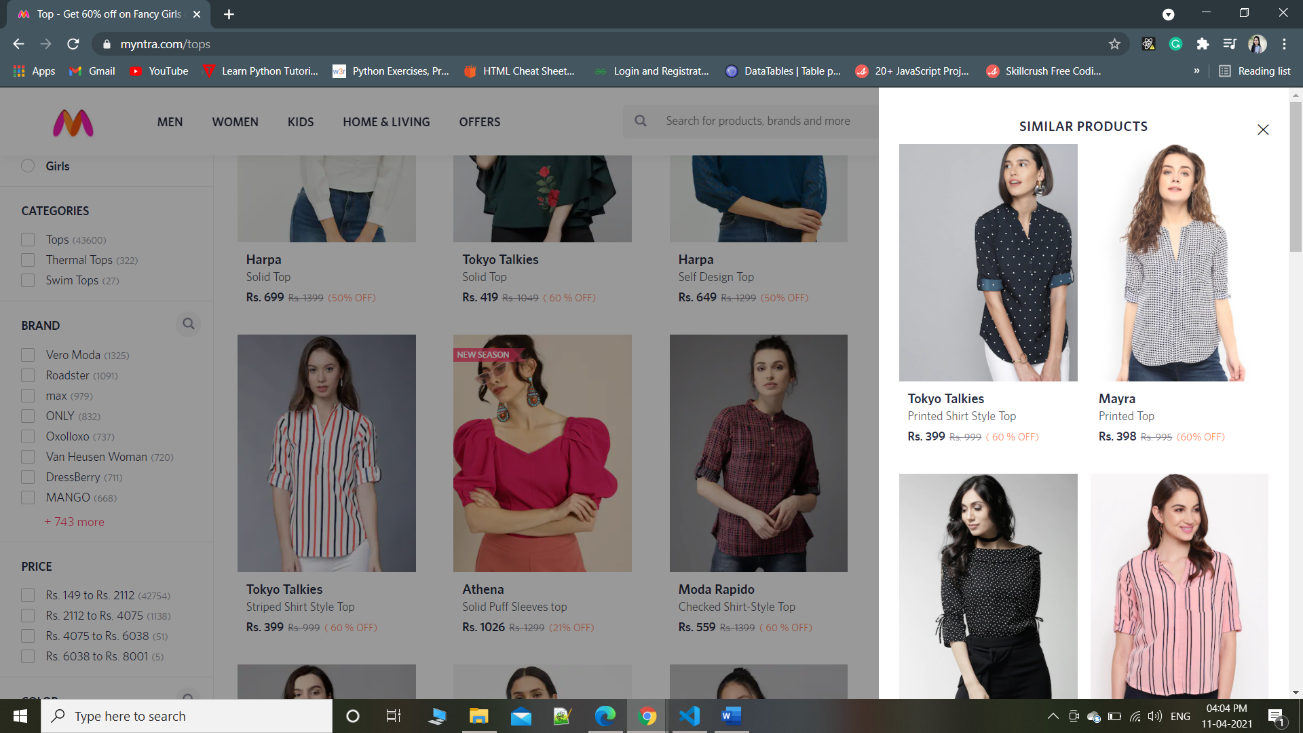

A good user interface enables users to complete the task that they came to the website to do with ease and without confusion. Myntra is responsive shopping website with good and user-friendly interface and easy to navigate which is easily understood by anyone. Filtering products is also easy in this website. we can find product which we want very easily. From searching product to buying, everything is easy. Smooth transition while navigating through navbar. When we hover over product its shows different images of product, we can see similar product in sidebar on same page.

1. **Pitch**

Pitch, a mobile and web application that helps you to build and manage beautiful presentations. Pitch has simple logo but we can see transition on most of items which gives good experience to user.

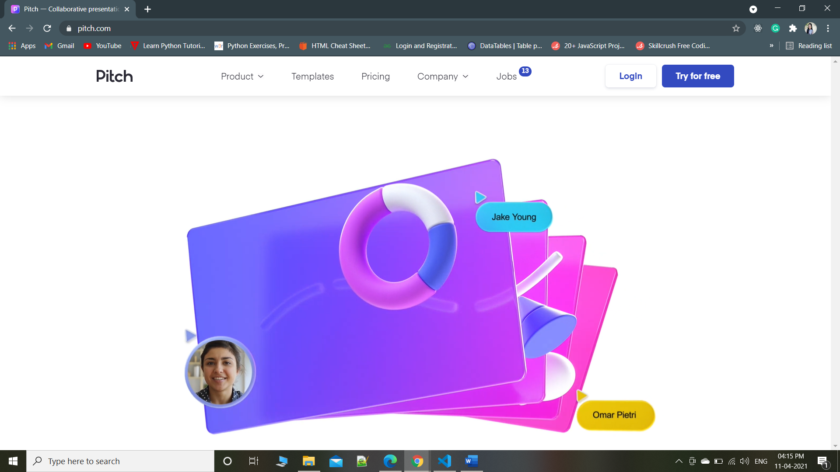

It has some smart, subtle dynamic elements and animations which bring the site to life and nudge the user from one scroll to the next. They gently draw your attention from right to left, and the delayed onset of each animation encourages you to pause at each product feature and benefit. Everything including Colour scheme, transitions seems professional. Wide range of templates, transition between template category looks good. User can easily find what template they want. Also It has responsive design.

1. **Airbnb**

The UI of Airbnb does two things very well: booking a place to stay, and creating trust between two complete strangers. When we scroll through website top section disappears which gives good experience to user. The UI here was clearly designed to ensure that a user can focus on completing their goal as quickly and efficiently as possible. Anyone who want break but not sure where to go Airbnb suggest them lot of option by few doing filtering. As shown in screenshot(1) below in which I did some filtering and it shows me a lot of nearby places in google map with prices (screenshot 2) where I can go .

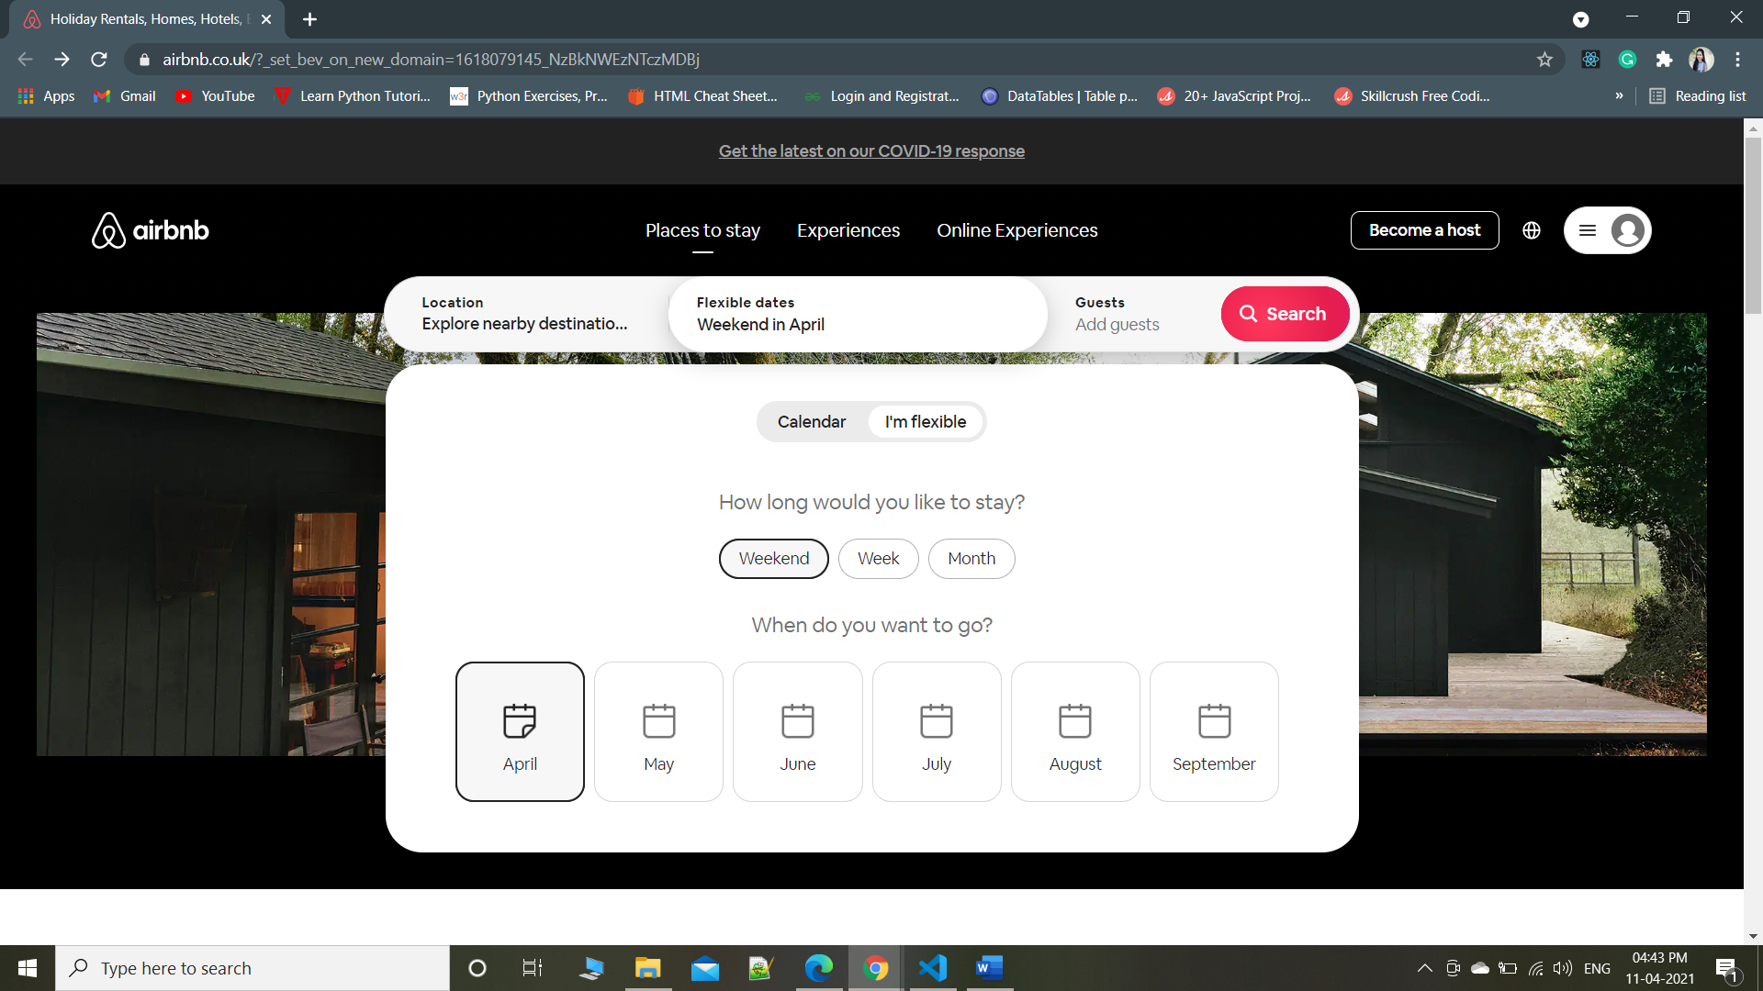

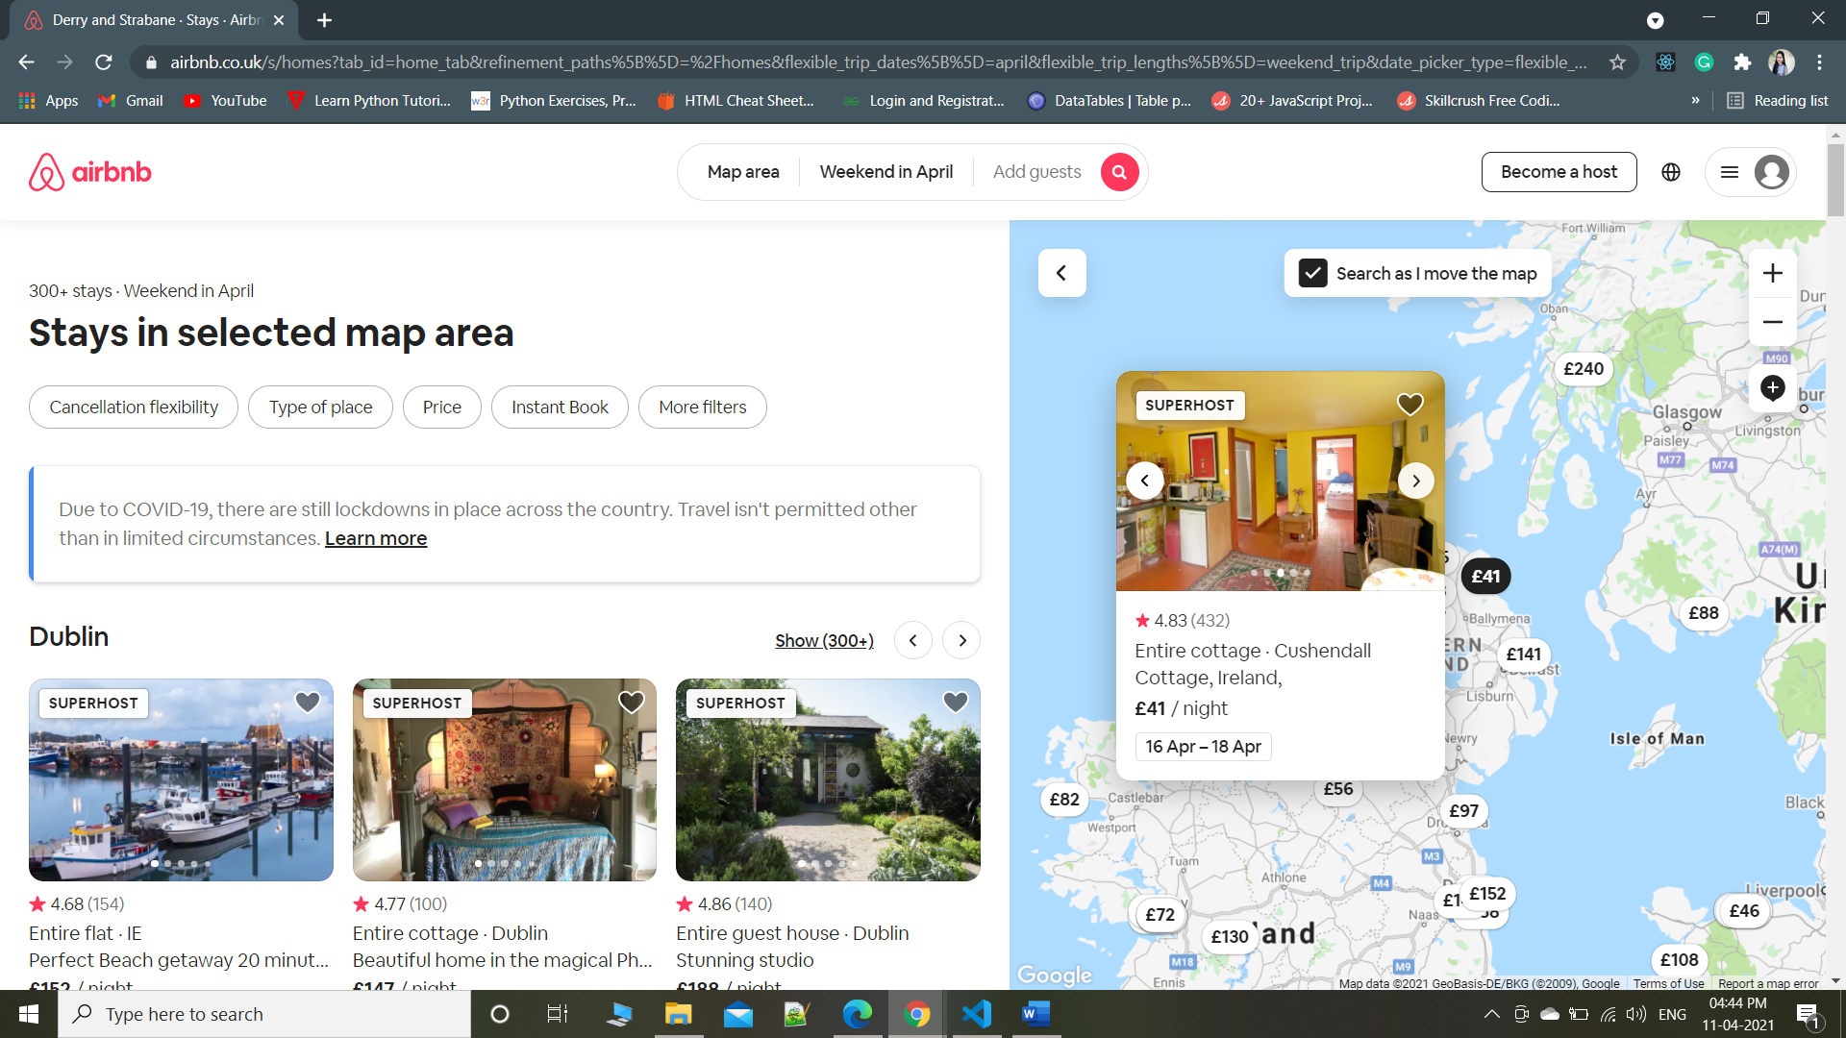

Airbnb has cleverly thought out its copy and used engaging photos and videos to ensure that the interface conveys an emotional tone that helps create a sense of trust between strangers. part which I don’t like is Airbnb is not responsive.